IMF-IRTF EY 2021 DATA LOAD
General Introduction of IMF/IRTF

The Individual Master File (IMF) and the Individual Return Transaction File (IRTF) Extracts are databases created from returns filed under the individual income tax reporting requirements of the Internal Revenue Code (IRC). The IMF/IRTF Extracts are developed by retrieving requested data annually based on the taxpayer's State code, ZIP code and taxpayer identification number (TIN).
Note:- Participants may enroll in the Extracts by State code not City agencies, ZIP Code or SSN.
The IMF/IRTF extract is Actually two separate extracts; however, since the IMF extract contains entity information and the IRTF extract does not, the two must be received together. These two extracts are usually referred to as one, using the singular grammatical form.
- The IMF Extract contains entity information (SSN, name, address, filing status) and some common/general return line items such as wages, adjusted gross income etc. transcribed from the Form 1040 series. Records may include data from an original return or an amended return posting during the Extract Year. This is a "living" file that includes data from adjustments for records based on an original return or an amended return posting during the Extract Year.
Note: Document Code in identifies the type of document filed.
- The IRTF Extract has fields from the Form 1040 series, and their accompanying forms and schedules extracted from the IRTF Database. This information contains "raw data" which means the items transcribed off the original/amended return are as the taxpayer initially submitted.

Processing Schedule
After the IRS receives the Optional Data Element Selections (ODES) each spring from the agencies enrolled, the IRS programmers use this information to develop various computer Extract programs. One National file is made during IRS computer cycle 34 (34th week of Calendar year which is the week ending August 26, 2021) extracting the most current IMF and IRTF data.
EY 2021 IMF/IRTF by Payee State Code:
This extract contains tax records which were posted during the past 12 months ending August 26, 2021 and sorted by State code. By the end of September of each year, each enrolled agency will receive all available data records for their State which were requested via the ODES process, any non-requested optional fields will be blanked out.

Generate Notice to Taxpayer using Notice Codes
(Cross-Reference to IMF Taxpayer Notice Codes (TPNCs) field on position, Positions 360 – 374)
Whatever generated three-digit numeric Notice Code(s) in Taxpayer Notice Codes fields use this code and send notice to taxpayer according to the TPNC code.
Current year Domestic Taxpayer Notice three-digit Codes are listed in Exhibit 3a followed by International Taxpayer Notice Codes listed in Exhibit 3b. Please refer to prior years' IMF/IRTF Extract Specification Books for prior year codes/explanations.
The three-digit numeric Notice Code(s) will appear in the IMF Taxpayer Notice Code field.The type of return for the record is identified in the IMF Document Code field (Exhibit 2: DLN Doc Code- position 4-5).

Note : For information, please refer IMF-IRTF EY2021 “SPEC” book

Note: - Check to see if the SPEC book is available and use this book to see if there are any changes from the IRS.
If there are any changes from the IRS, then need to update the mapping documents, SSIS package and scripts following the spec book.

IMF-IRTF EY2021 DATA LOAD - (PPTEST)
- Make sure all Folder and Paths should match with previous years
- Create an Integrated Services new project from Visual Studio
- Browse path in ETL folder for current project year and create "IMF-IRTF_2021" within that folder
- Delete Package.dtsx (By default created)
- Right-click on SSIS package and add existing package from previous year and rename to match current year
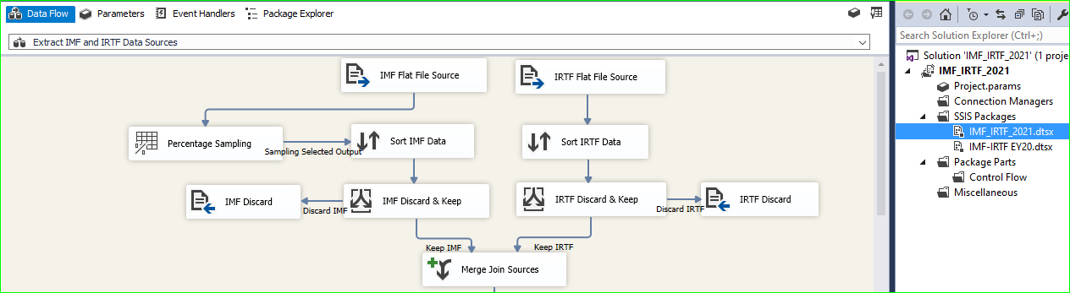

- Hit on Database connection manager and update it according to the requirement, Server Name should be
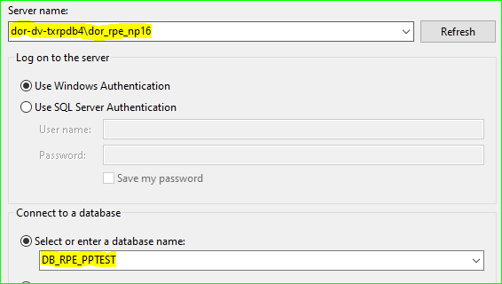
DOR-DV-TXRPDB4\DOR_RPE_NP16 and database name should be DB_RPE_PPTEST.

- IMF-IRTF Package have a two separate source files (ETL will Join merge IMF and IRTF common records - Left outer join)
Note:- Participants may enroll in the Extracts by State code not City agencies, ZIP Code or SSN.
IMF-IRTF source file: (1). PDIEY.I80707ST.FRI105.X202134.txt (IMF) (Demographic Information)
(2). PDIEY.I80805ST.FRI105.X202134.txt (IRTF) (Financial Information)
- Open the IMF_IRTF_2021.dtsx SSIS package and update the Source file connection string (make sure source files should proper connected).
Note:- For more ELT information Kindly please refer ELT Technique and Logic file
- Update database connection, server name should be DOR-DV-TXRPDB4\DOR_RPE_NP16 and database name DB_RPE_PPTEST
- Create Mapping documents and update it following as a current year and SPEC book changes as well as needs to apply those spec book changes into the ETL.
- Open the variable window and update variable as per data load year.
Variable Mapping

Need to edit SRC RUN ID, File Name, and file Path as per data load year.
- IMFInputFileName : PDIEY.I80707ST.FRI105.X202134.txt
- InputFilePath : \\dor-dv-txrppw1\RPPW\Data_Sources\Federal\IMF-IRTF\EY2021\source
- IRTFInputFileName : PDIEY.I80805ST.FRI105.X202134.txt
- OutputFilePath : \\dor-dv-txrppw1\RPPW\Data_Sources\Federal\IMF-IRTF\EY2021\source
- SRC_RUN_ID : 2003121000
- Execute the IMF-IRTF_2021 SSIS Package to load data into below listed AIF Tables (make 1% Percentage sampling in SSIS package – don’t need to load full set of records just 1% enough for testing purpose)
- AIF
- AIF_ENTITY_INFO
- AIF_RELETIONSHIP
- AIF_INDIVIDUAL_INFO
- AIF_FINANCIAL_DETAIL
- AIF_LINE_ITEM_DETAIL
- AIF_GENERAL_INFO
- Verify all AIF tables, meanwhile ETL execution if record went to Discard then verify those IRM and IRTF records.
- Create TFS and make sure needs to follow proper TFS workflow and it should be UpToDate according to work status.
- Create 001, 002, 003, 004 scripts (If spec book has a change, then we need to apply those changes in 001 script)
- 001 script :- Insert reference data for IMF-IRTF
- 002 script :- Security related script
- 003 script :- Update “Blank” in AIF_LINE_ITEM_DETAIL to NULL
- 004 script :- Update “Dashes” in AIF_LINE_ITEM_DETAIL to NULL
- Execute 001,003,004 script in PPDEV_Playground environment for any errors or unwanted statements.
- Attached all supporting documents into the TFS (SPEC book, mapping doc, readme file, unit testing checklist, scripts, QA Testing ID’s, etc.
- Assign TFS (script) to Dan L for peer code review
- Assign TFS (Script) to Colin for run in PPTEST Environment.
- Name Parsing Rules (Need to check AIF_VALIDATION_CONFIGURATION table before run AIF)
- Parse IMF-IRTF column needs to be “Y” for individual records b/c IMF-IRTF has an individual records
- update statement (update AIF_VALIDATION_CONFIGURATION set PARSE_IRMF_NAMES = 'Y' ) to 001 script (run before AIF Validation)
- If load has both individual and business records, run individual first, run the script again (update AIF_VALIDATION_CONFIGURATION set PARSE_IRMF_NAMES = 'N' )
Note: Every RI Data loads the AIF_VALIDATION_CONFIGURATION table field "PARSE_IRMF_NAMES" should be updated to 'Y' before AIF Validation for Individuals but for the Business records leave then 'N'
- Run the AIF validation
- Run below SQL Query into the PPTEST to make sure an error for AIF validation process (Need to change SRC RUN ID for current data loads)
- SELECT aif.entity_id,
AIF.src_entity_id,
ETL_SOURCE_RUN_DETAIL.DATA_SOURCE,
DATA_SOURCE_DETAIL.DESCRIPTION,
AIF.SRC_RUN_ID,
AIF.STATUS
FROM AIF
INNER JOIN ETL_SOURCE_RUN_DETAIL
ON AIF.SRC_RUN_ID = ETL_SOURCE_RUN_DETAIL.SRC_RUN_ID
INNER JOIN dbo.DATA_SOURCE_DETAIL
ON DATA_SOURCE_DETAIL.DATA_SOURCE = ETL_SOURCE_RUN_DETAIL.DATA_SOURCE
WHERE AIF.SRC_RUN_ID = ‘2003121000’
and AIF.STATUS = 'error'
- select * from AIF where src_run_id = 2003121000’and validation_flag = 'E'
- Run NameHold script (Need to change SRC RUN ID according to the data load and years)
UPDATE a
SET a.status = 'NameHold'
FROM AIF a
WHERE a.src_run_id = 2003121000
AND a.status = 'Research'
AND a.src_record_num IN (
SELECT src_record_num
FROM aif_entity_info b
WHERE a.src_run_id = b.src_run_id
AND entity_name IN (
SELECT entity_name FROM COMMON_NAMES WHERE COUNT > 100
))
- Run AddHold scrip (Need to change SRC RUN ID according to the data load and years)
UPDATE a
SET a.status = 'AddrHold'
FROM AIF a
WHERE a.src_run_id = 2003121000
AND a.status = 'Research'
AND a.src_record_num IN (
SELECT src_record_num
FROM aif_entity_info b
WHERE a.src_run_id = b.src_run_id
AND (address_line_1+city+state_province) IN (
SELECT address_line_1+city+state_province FROM COMMON_ADDRESSES WHERE COUNT > 100
))
- Kick off the A&G validation (Need to process only (1%)/1000 records just for testing purpose in the PPTEST but for the Prod need to process for all entire records)
- Create QA Testing ID’s and attach into the TFS
- QA Testing STAARS vs AIF tables.

Unit testing/Validation Process:
- Load only 100/1000 records in PPTEST. (Depend on data load) but for the PROD need to load full set of records.
- Make sure to attach the unit testing checklist, readme txt, mapping doc, spec book, Testing ID’s etc. to the TFS. Review TFS-84877 for the template format and information.
- Verify all AIF and PW tables making sure the correct data source and source run id is loaded.
- Verify AIF tables name is parsing correct for individual vs business entity type.
- Verify Account_Type and Filing_entity column data and make sure it is loaded correctly with RI values. Compare with previous year.
- Pick two entities from source file and validate it against the AIF tables.
- Check spec book/mapping document changes applied correctly to the AIF tables and for the application, buckets updates, form line/description updates etc.
- Pick two or more entity where the bucket/form change and test it via RPE.
- Pick two or more entity and verify on RPE via multiple screens and navigation, example views menu, entity menu, data source summary tab etc.
- Identify Research and Grow entity population. Why it went to Grow or Research?
How to Do QA Testing with STAARS: Please find more detail in “How to QA Test in STAARS” doc file.
\\ent-fs-vm001.enterprise.ri.gov\dor-taxation\shared\its\Team Folders\Mukesh\Project Documents\AIF-A&G-STAARS-JAMS_Documents (Mix)\STAARS_Validation\Validation_STAARS
- Assign TFS to Verdier Michael for the State Retest (Make sure all supporting doc should be attached)

DATA MIGRATION TO THE PROD STEPS

- After Get Sign off from Testing side (Kimberly) Load data into the PROD.
- change connection string in SSIS package for the Prod environment
- change percentage sampling in SSIS package make 100%.
- Execute the IMF-IRTF_2021 SSIS package
- Verify all AIF tables loaded proper
- Assign TFS to Colin to run 001,002,003 and 004 scripts in the PROD
- Assign TFS to Jon H to do AIF and A&G validation in the PROD
- Kick off the AIF validation process for PROD – Jon Heroux will run AIF validation
- Kick off the A&G validation process for PROD (Full set of Records) – Jon Heroux will run A&G validation
- Verify all AIF tables into the PROD environment.

AIF VALIDATION STEPS
Note: The AIF Validation Process almost similar steps for all data loads, but for Individual records need to select “Individual” in the admin tool and “Business” for business records moreover if records mix match like Individual and Business together then need to select “Both” in the admin tool. (Need to select “Individual” for IMF-IRTF)
- Make sure the data successfully loaded into all AIF tables and right data populated with the right fields.
- Open the Admin Tool and select proper Network Name/IP for PPTEST
PPDEV: dor-dv-txrpdva1.dor.ri.gov
PPTEST: dor-dv-txrpsta1.dor.ri.gov
- Hit on Offline Process button and select AIF Validation
- Insert SRC RUN ID and Beginning and End source records number, beginning source records number should be “1” and End source should “1000” or max records (99999999)
- Select Name Parameters according to the data loads (The IMF-IRTF has an Individual records so need to select “Individual”) and Hit on Start Button
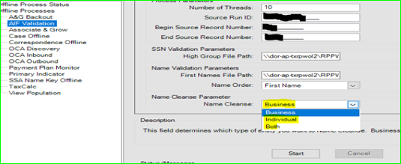

- If have any error check Log file. (\\dor-dv-txrpdva1\Wildfly\standalone\log).
- After the AIF Validation need to make sure all records processed. Run below SQL Queries together and count should match with both queries. As well as Validation_Flag field should be populated “Y”, Entity ID = “Null” and Status = ”Loaded”
select count (*) from AIF where src_run_id = 2003121000 and Validation_Flag = 'Y'
select count (*) from AIF where src_run_id = 2003121000

A&G VALIDATION STEPS
- Open the Revenue Premier Administrator tool and click on Offline Process button.
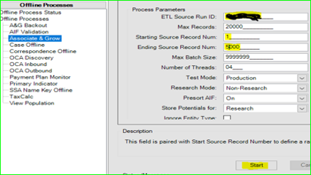

- Select Associate & Grow and Insert SRC RUN ID: - 2003121000
Note : Needs to follow the stranded rule of A&G validation, take only 10 records and process, and verify all AIF tables, PW tables as well as do QA Testing with STAARS vs AIF tables according to the Unit testing checklist and if A&G results is satisfied then process other remaining records. (Generally, needs to do A&G process for subset records just for testing purpose – 1K Records)
- Starting Source record = 1 , Ending Source record = 10 , Number of Thread = 1 and hit on Start button.
- If have any error meanwhile A&G process, please check Log file (//dor-dv-txrpsta1/WildFlyLogs/DAL-log.html)
And make sure If have any error meanwhile A&G process need to back out those 10 records.
- Verify all AIF tables, PW tables and do QA Testing STAARS vs AIF tables
Note: Make sure Account_type should be “IIT”, Filling_Entity should “N” and Source Name should be proper parsing and populated as a Fist Name, Middle Name and Last Name in the AIF_ENTITY_INFO table.
- Kick off again A&G process and now take Starting Source record = 11 ,Ending Source record = 1000, Number of Thread = 10/20 and hit on Start button. (Ending Source record depend on data loads)
- After the A&G validation AIF table Status field should be populate with “Assoc/Grow/Research” with Entity Id, The A&G Process also does data load into the PW Tables.

Note:- When we run the A&G validation, A&G will be match data with the prior year warehouse data and if Incomeing data match with prior year data then records will go to an Associate and if not match then records will go to Grow but Incomeing data not reliable then it will go to research.
============================================================================================

